Data retrieval and processing from the I22 beamline at Diamond Light Source
This guide will guide you through how to access and download raw SAXS data after a beamtime at Diamond Light Source and how to perform background subtraction using DAWN 2.27 on your raw data files.
- Data retrieval from DLS
Diamond offers several ways to access data after a beamtime, which can all be found here: https://www.diamond.ac.uk/Users/Experiment-at-Diamond/IT-User-Guide/Not-at-DLS/Retrieve-data.html
In general, for accessing small datasets, the fastest way is to use a File Transfer Protocol (FTP). Note here that if you are trying to download data off the system on campus (using eduroam), you will need to use Secure FTP (SFTP), as the university blocks FTP. A detailed guide can be found on the diamond website at: https://www.diamond.ac.uk/Users/Experiment-at-Diamond/IT-User-Guide/Not-at-DLS/Retrieve-data/in40days/ftp.html
As an example, in this section we will go through a quick example on how to retrieve data using a client software such as WinSCP.
  - Retrieving sets of data using WinSCP
The screenshot below shows the start-up dialog of WinSCP. To access data, choose the file protocol as ‘SFTP’ and use the Host name “nx.diamond.ac.uk”, keeping the port no. at 22.
Then insert your FedID and FedID password in the slots of the Username and Password. These should have been sent to you by Diamond after passing the safety tests and will be in two separate emails. Searching federal ID in Outlook is typically the fastest way to find these back.
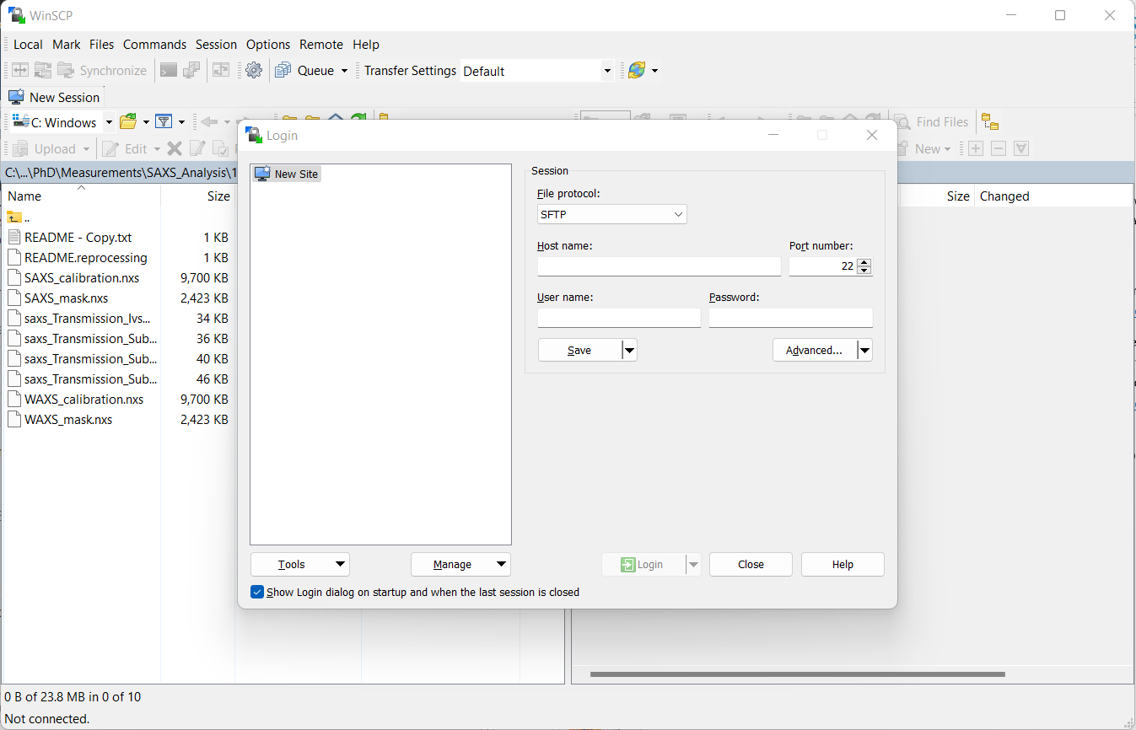
Once you have added in all the data and hit Login, a certificate warning will pop up, click “Yes”.
Then, two windows will show (below), the one on the left being a folder in your laptop, while the one on the right shows your account data on the Diamond servers. You can navigate in the top left to your selected folder where you want to keep your SAXS data.
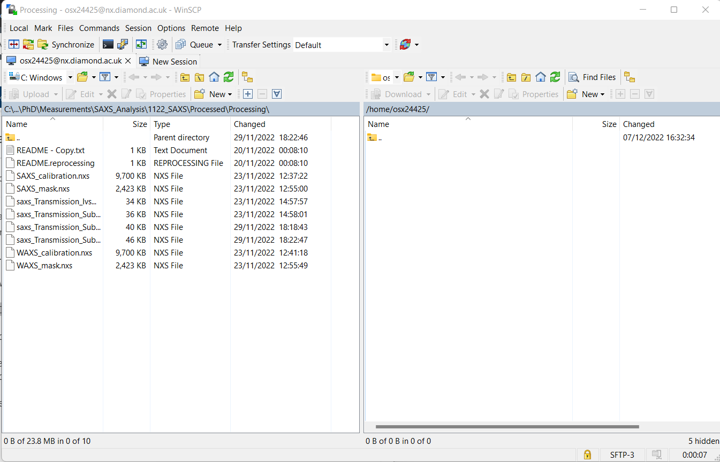
Using the navigation on top of the right-window (circle in the screenshot), you can find your experiment folder by going back to /root, then go through the pathway from the folder dls/beamline/data/year/experiment number. In the screenshot below, we have accessed the data from a beamtime at I22 (sm32097-1) from 2022. (/dls/i22/data/2022/sm32097-1/)
e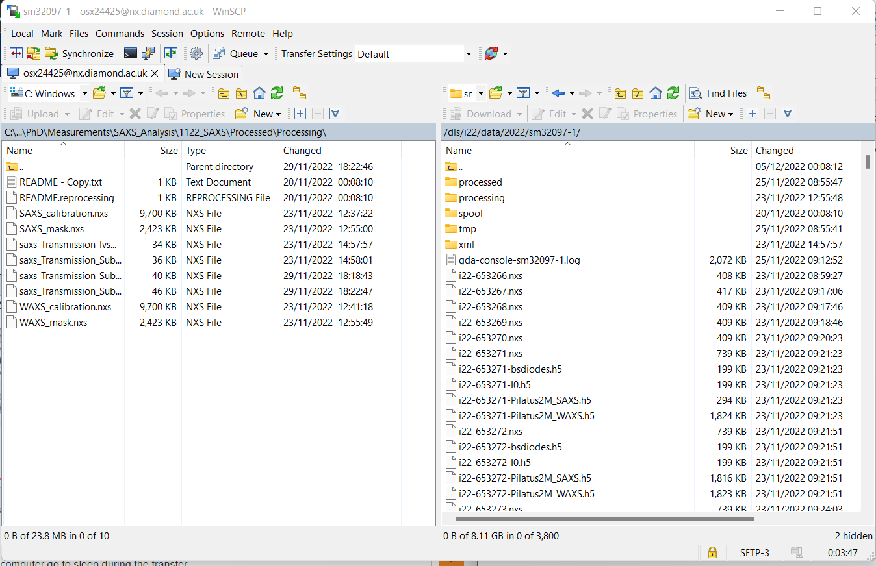
The folder will contain all the raw data collected from the SAXS detector, with various file types. The .nxs files are the ones you will require if you need to perform your own background subtraction. To transfer the data the files simply need to be selected on the right and dragged to the left folder. Make sure your laptop doesn’t turn off during this process!
There are other folders present in the experimental data folder, which will come in handy when you will set the background subtraction pipeline. The “processed” folder generally contains .nxs files that have been already processed at Diamond by your beamline scientist, i.e. where the background has already been subtracted. There is a chance that your samples won’t all have the same background, and in some cases the background subtraction set at Diamond is just subtracting air/empty beam. If you have the same background file for all samples, you can ask your beamline scientist to set up a processing pipeline including this file as background after you record the scattering, and this data will then be found in the “processed” folder. The “processing” folder contains all the relevant information for the second part of this guide, the background subtraction pipeline. In particular, this folder contains the SAXS/WAXS calibration performed by the beamline scientist prior to your time at Diamond and a SAXS/WAXS mask for the detector. This will be also made by the beamline scientist during your first measurements at Diamond and it is simply a way to mask invalid pixels or the beamstop to avoid them reducing the quality of your data/scattering patterns. If you have flares in your data, you might require changing the mask file, as will be explained in a later section. The processing folder also contains a .nxs file containing a background subtraction processing pipeline already set-up by the beamline scientist that can be loaded into DAWN, with a name along the lines of “saxs_Transmission_IvsQ_Pipeline.nxs”. In the next section, we will walk through each step of this pipeline.
- Background subtraction pipeline using DAWN 2.27
  - Download DAWN 2.27
DAWN science is an application developed by beamline scientists to facilitate visualisation and analysis of data from any synchrotron experiment. Many beamlines operate using DAWN, such as the ESRF and Diamond. DAWN is free to download and can be found here: https://dawnsci.org/. The website itself is quite useful as it contains guides, videos and cheat sheets to learn how to use the software. When opening the software, you will observe the following screen.
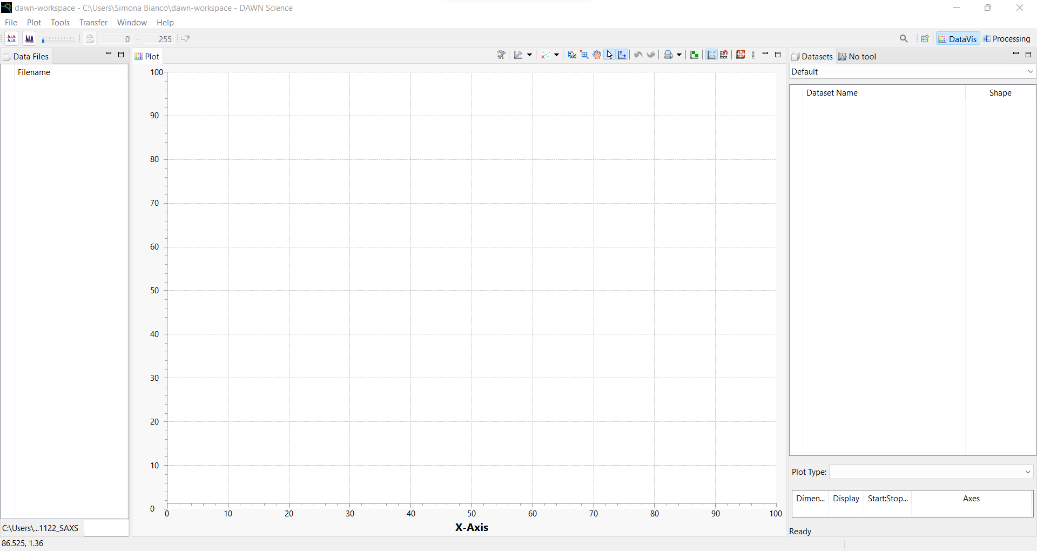
This is the data visualisation workspace, which we might use later on to have a look at our scattering patterns or 2D images, or to have a rough idea of our raw files. To start the pipeline subtraction, we need to navigate to the Processing workbook, in the top right (see circle). This will look like the screen below:
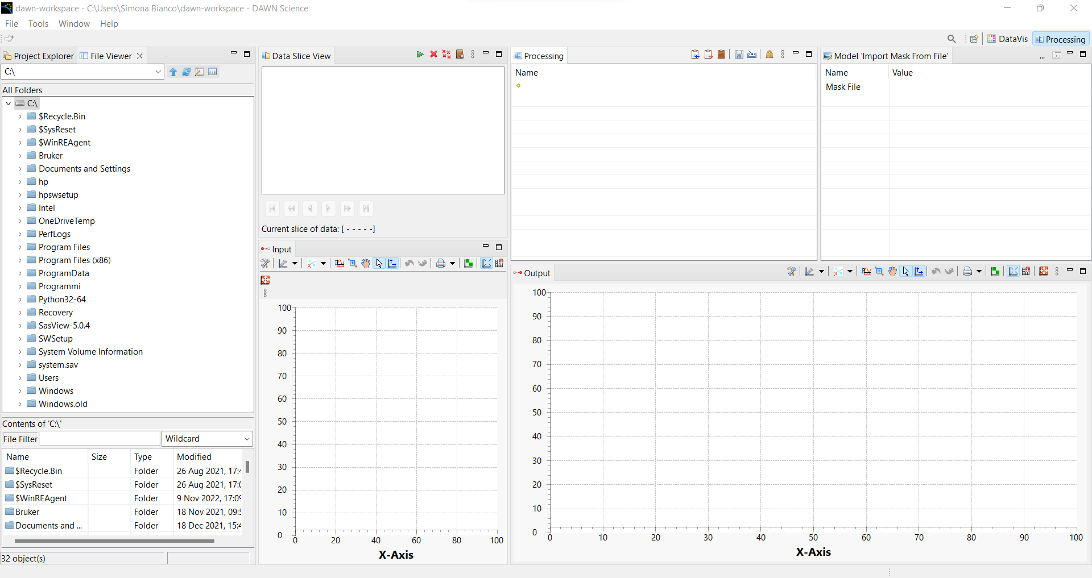
In the “Processing” tab, your pipeline will be set. If there is a previous pipeline provided by the beamline scientist, you can directly load, clicking the 5th button (near the saving icon). An example pipeline that I prepared will also be provided alongside this guide to allow you to speed-up the process. Once you have loaded your pipeline, you will have a Processing tab looking like this:
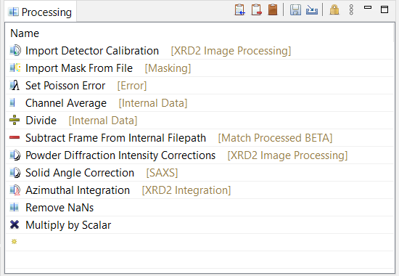
This is the general pipeline provided by I22, for a more mathematical explanation of all the steps, the reader is referred to: ¹. In the next section, we will walk through all the steps of the processing pipeline to gain a general idea of the order and meaning of such pipeline.

  - Processing Pipeline
At the start, before data correction, the data must be read-in by the program. This can be done by navigating through the files in the File viewer and dropping the raw .nxs data files of your samples in the Data Slice View (Figure 1, left). Here, you can drop multiple files to perform batch processing of your samples. When the file is dropped, a new window will pop-up, asking you to find the data directory containing the 2D image collected from the SAXS detector.
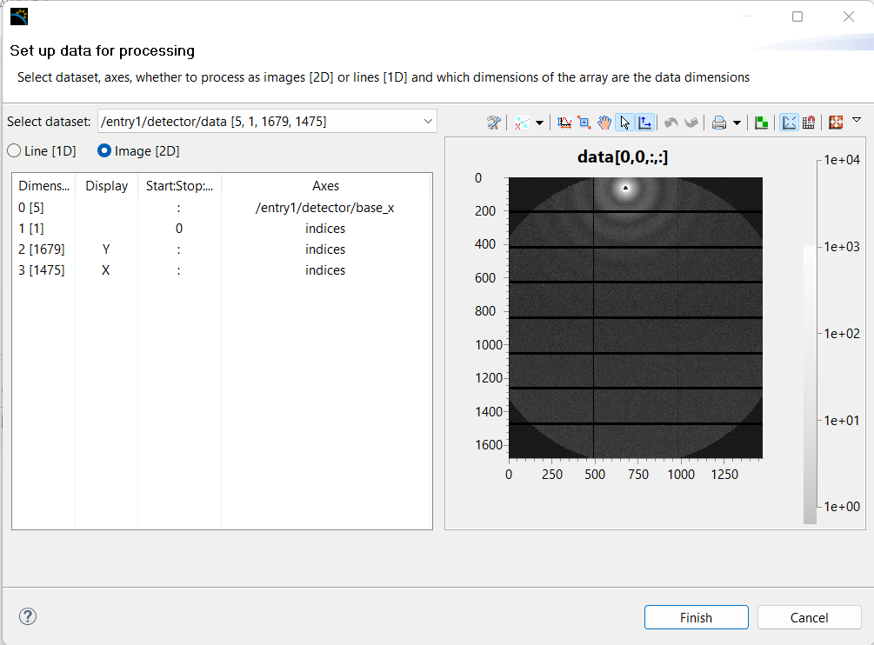
Ideally, the dataset should be automatically selected. If this is not the case, the dataset is generally found in /entry1/detector/data. Once you have confirmed this, click finish and your sample will be loaded in the data slice view.
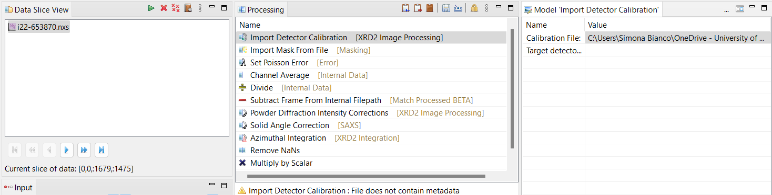
The first two steps of the pipeline require importing the calibration of the SAXS detector and a masking file. In general, both files should be provided by the beamline scientist and should be accessible from your experiment folder in the I22 remote system, generally called SAXS_mask.nxs and SAXS_calibration.nxs . Note here that the masking step allows to mask all invalid pixels, such as dead pixels and the beamstop. Although the mask is typically provided by the beamline scientist, specific samples may contain further invalid pixels due to cosmic rays or flares. As a result, the mask might need to be manually done again by the user through DAWN (See section 2.3.1). To upload this file, click on the step of the pipeline and navigate using the tab on the right to where the calibration file is found (right tab on the figure). Once these two files have been uploaded, you should be able to see your Input 2D image as an output 2D image with the mask on (green lines):
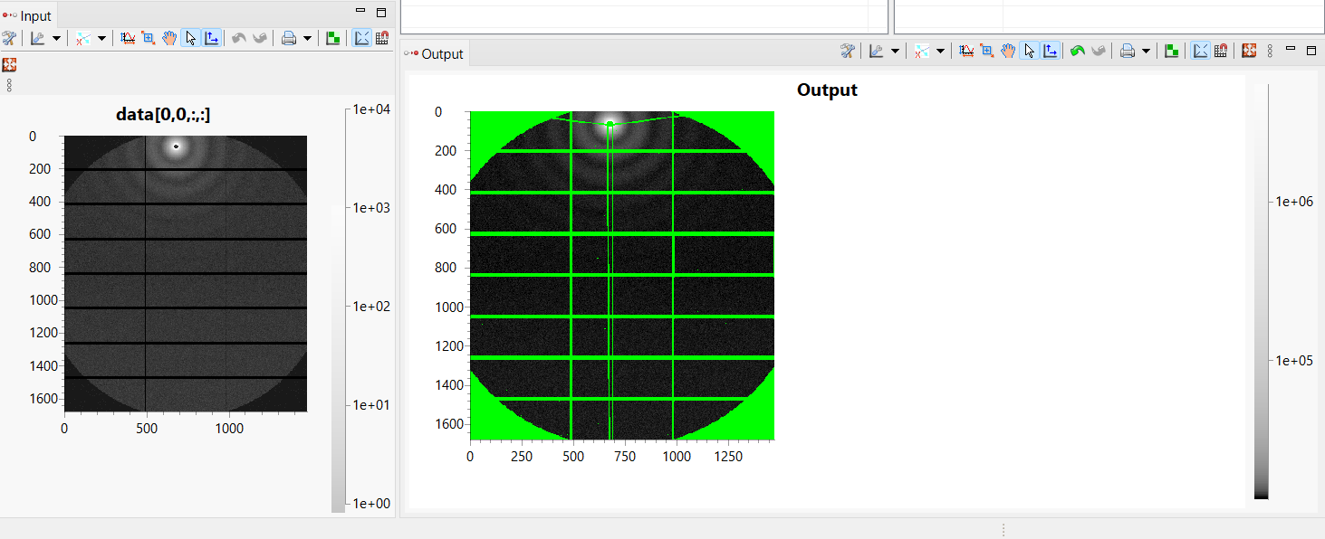
After this is performed, the Poisson error due to the counting uncertainty based on the number of detected photons on the detector face needs to be calculated. This can be done by adding the Set Poisson Error step, which has no options and simply needs to be added to the processing pipeline. The next step corrects the signal for time, flux and transmission, to render the measurement independent respectively on duration, incident beam flux and correct for the probability of absorption within the sample. For current I22 data, all three of these corrections can be applied through a single step, performing a Divide [Internal Data], connecting to the internal data that contains the transmitted intensity information. This data will be found in the data set /entry1/instrument/detector/count_time and can be found through the drop-down box in the model view. Note here that for other instruments these corrections may vary, so knowledge of how the diode collects the transmitted intensity is needed. This will allow the user to know if further reduction steps need to be added to the pipeline.
Once all the steps are added, we can now perform subtraction of our beamline background, which typically can be the bulk solvent or just an empty cell measurement. In general, it is suggested to perform background subtraction of first air, empty cell and then solvent. However, it can be assumed that the instrumental background is included in the frames of the solvent, so it might not be necessary and simply subtracting the data using the Subtract [Match Processed BETA] can be enough to perform subtraction. Here, you can link your background file (.nxs raw data) and specify the file that it is to be subtracted, found in the datasets of either /entry1/detector/data or /entry1/Pilatus2M_SAXS/data. This step will apply all the previous steps in the chain to the background frames and subtract the result from the current file. The “Subtract” model also includes a Scaling option. This should be considered if the sample under investigation is at high concentration and thus might have displaced a significant amount of solvent. A scaling factor can then be included to avoid over-subtracting the solvent from the analyte sample (See section 2.3.2).
Then, angular efficiency, solid angle and polarisation correction will be applied through the same processing step: Powder Diffraction Intensity Corrections. For I22, the beam polarisation factor is always of 0.9, while the detector transmission factor will change with respect to energy. For 12.4 keV, 0.1678 should be the value to insert. If other energies are used, your local contact can be able to provide these for you. These can also be obtained by navigating through the metadata file provided in the beam time files.
The final step here is then to reduce the data from a 2D image to a line plot using the Azimuthal Integration processing step (I vs q data). This data will now be shown in the output panel as 1D scattering pattern. Finally, to scale the intensity of the data, the data is typically scaled against a calibrant, in the Multiply by Scalar step. The value should already be provided by your beamline scientist, in this case 3.8E-15.
As the pipeline is now complete, you can perform background subtraction on the file(s) in the Data Slice View by pressing the green play button. This will perform all the steps we have gone through and output a 1D scattering image, as shown below. The data will also be exported automatically as a .nxs file in the output path chosen by the user.
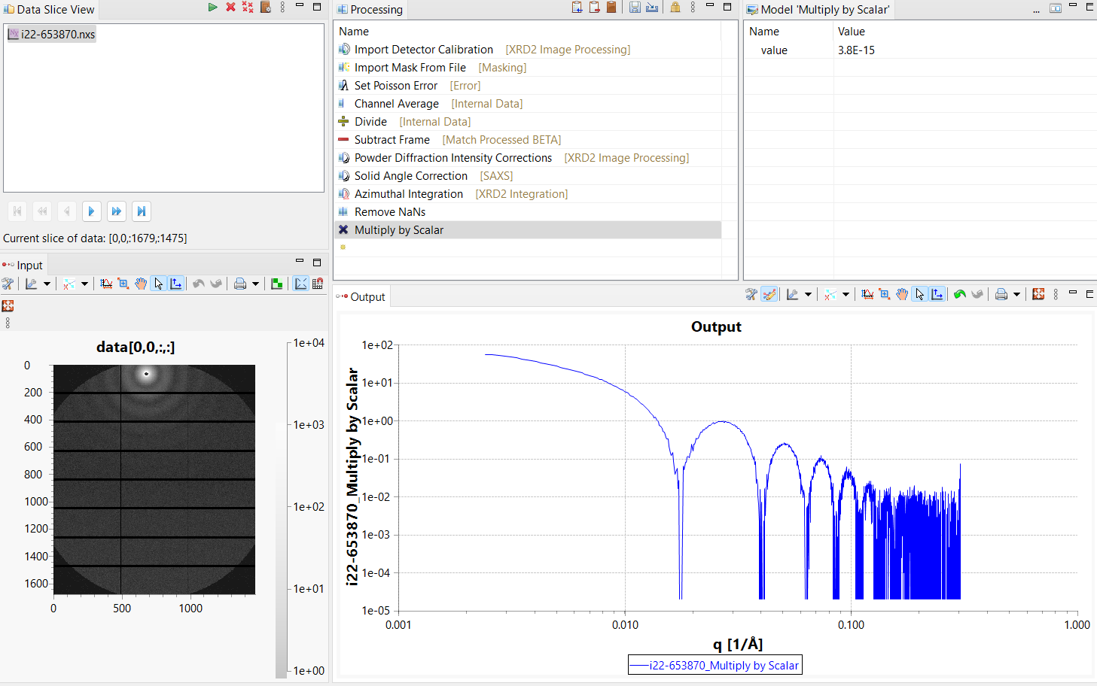
Note: the data in the output area might be shown in a linear-linear scale. To observe log-log, simply click on the graph and press x, y on your keyboard!
The data is now ready to be used to perform fitting and analysed. In order to obtain a text file, a new step in the Processing pipeline can be added, using the first icon button in the Processing tab. The step is called Export to Text File. Performing this will provide a .dat file (or .txt) containing three columns: 1) q, 2) I, 3) I_{err} and can be directly loaded into SASview for further analysis.
  - General Problems
In this section, we will quickly have a look at some issues that can be encountered when performing background subtraction in DAWN.
    - Fixing oversubtraction
If your sample scatters weakly, the background subtraction might result in large error bars at high Q. In DAWN, the intensity of the background data can be reduced to avoid this effect.
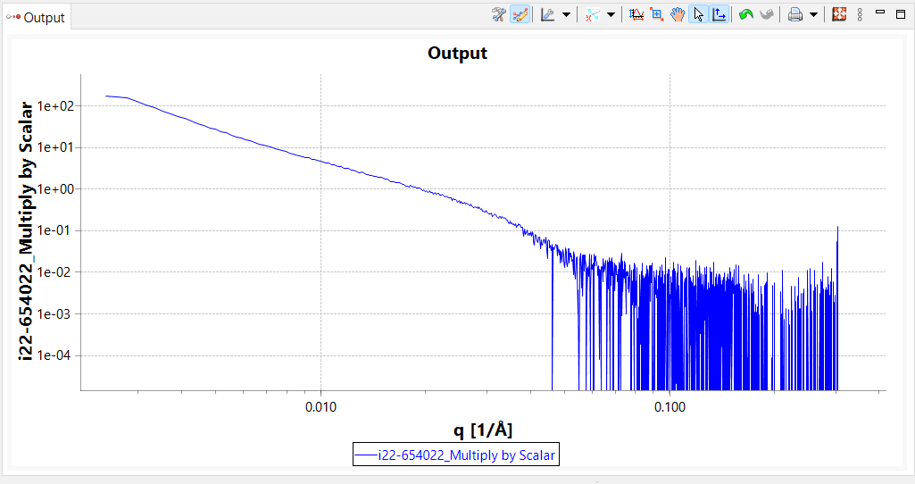
In order to reduce the intensity of the background, go to the Subtract Frame step and slightly change the “Scaling”. Reducing the Scaling factor from 1 to 0.9 already yields data that has much lower error bars in the high q region (See right).
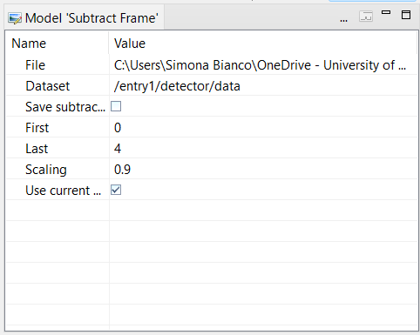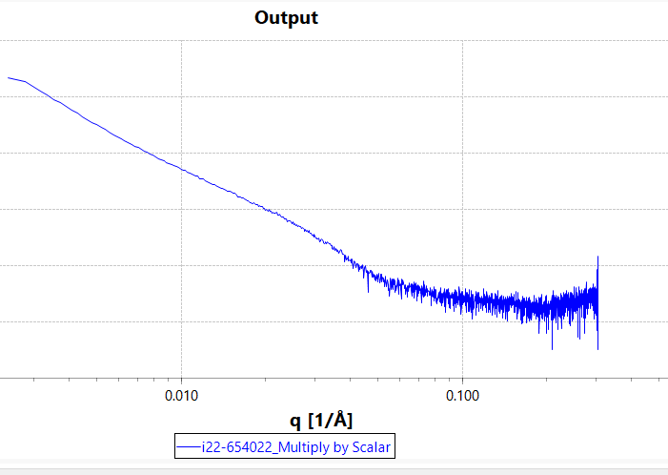
    - Making a new mask

